Sales Dashboard (Power BI)
📌 Brief Summary
An interactive Power BI dashboard that analyzes sales data to provide actionable business insights and support data-driven decision-making.

📖 Overview
This project focuses on building a comprehensive sales analytics dashboard using Power BI. The dashboard transforms raw sales data into meaningful visual insights, helping users understand business performance, trends, and key metrics.
It enables stakeholders to monitor sales performance, identify growth opportunities, and make informed strategic decisions through interactive visualizations. Sales dashboards typically highlight KPIs, trends, and regional performance to improve business outcomes.

📂 Dataset
- Source: Sample / public sales dataset (Excel / CSV)
- Data includes:
  - Order details
  - Sales amount
  - Profit & quantity
  - Customer segments
  - Product categories
  - Region / location data
  - Date & time (for trend analysis)
- Dataset

🛠️ Tools & Technologies
- Power BI – Data visualization & dashboard creation
- Microsoft Excel / CSV – Data source & preprocessing
- DAX (Data Analysis Expressions) – Calculated measures & KPIs
- Power Query – Data cleaning & transformation

🔍 Key Insights
- Identifies top-performing products and categories
- Highlights sales trends over time (monthly/yearly)
- Analyzes regional performance and customer segments
- Tracks key KPIs like total sales, profit, and quantity
- Helps detect seasonal trends and business growth patterns

📊 Dashboard
The dashboard includes:
- KPI cards (Total Sales, Profit, Quantity)
- Sales trend analysis (time-based visuals)
- Category & segment-wise breakdown
- Region-wise performance analysis
- Interactive filters (slicers) for deep insights
- Dashboard
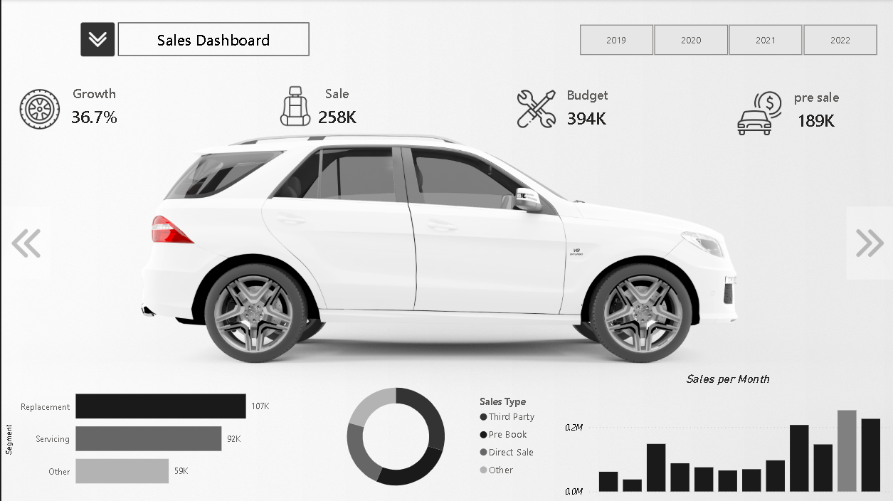
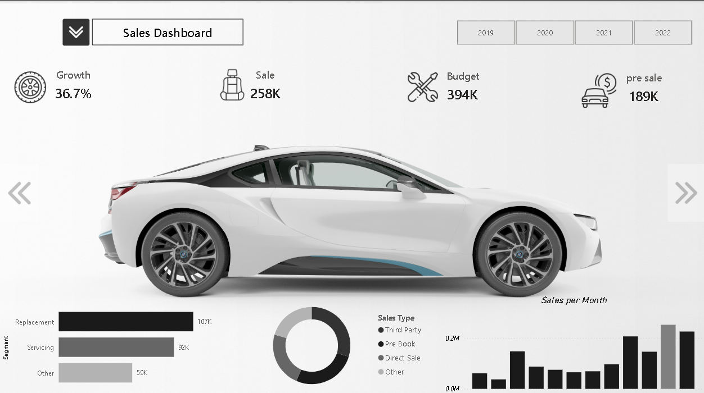
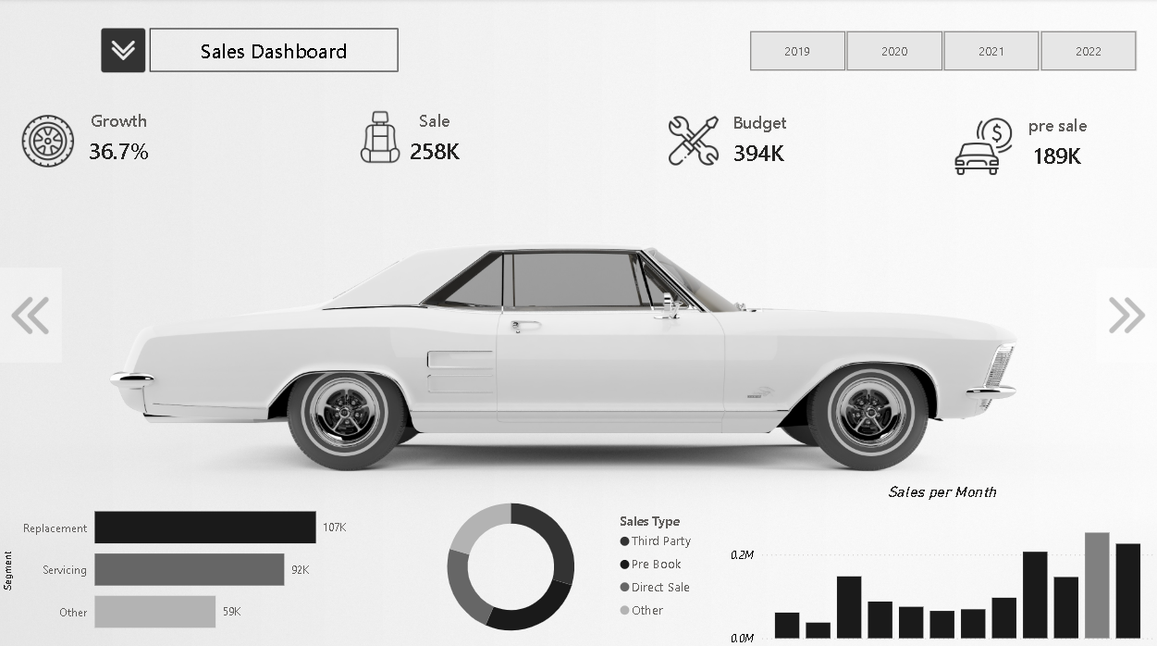
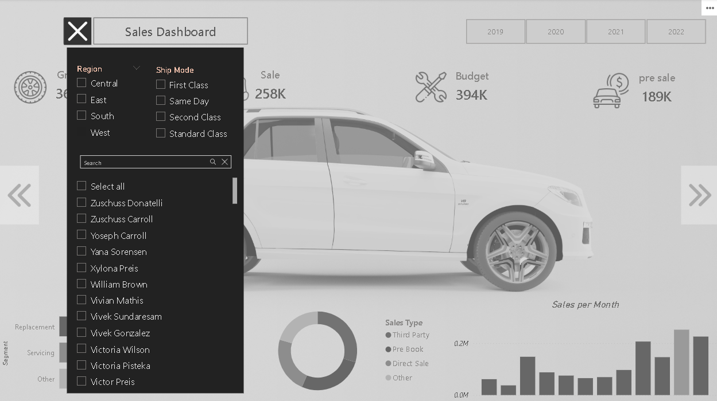
⚙️ How to Run This Project
1. Clone the Repository
git clone https://github.com/surya999610/Sales-Powerbi-Dashboard.git
2. Open the Project
- Open the .pbix file using Power BI Desktop
3. Explore Dashboard
- Use filters (region, category, date)
- Interact with visuals to explore insights
📁 Project Structure
Sales-Powerbi-Dashboard/
│
├── Sales Dashboard.pbix # Main Power BI dashboard file
├── Sales Data.xlsx # Dataset used for analysis
│
├── 📂 icons/ # Icons used in dashboard
│
├── 📂 images/ # Screenshots of dashboard (for README preview)
│
└── README.md # Project documentation
📈 Result & Conclusion
- This project demonstrates how sales data can be transformed into meaningful business insights using Power BI.
- The dashboard helps in:
- Monitoring business performance
- Identifying trends and patterns
- Supporting strategic decision-making
- It showcases strong skills in data analysis, visualization, and business intelligence, making it a valuable portfolio project.

